ASSIGNMENT SUBMISSION COVER SHEET

Student Id: CSE24-118

Student names: BOAGO PABLO NKHII

Student email: cse24-118@thuto.bac.ac.bw

Cohort: 2025

Assignment title: CSE202- OBJECT ORIENTED ANALYSIS & DESIGN WITH JAVA

Date of submission: 19-09-2025

Programme of Study: CSE

Year of Study: 2

Intellectual property statement By checking the box below, I certify that this assignment is my own work and is free from plagiarism. I understand that the assignment may be checked for plagiarism by electronic or other means and may be transferred and stored in a database for the purposes of data-matching to help detect plagiarism. The assignment has not previously been submitted for assessment in any other unit or to any other institution. I have read and understood the Botswana Accountancy College plagiarism guidelines policy. ☐ Agree Signature……………………………………. Date………………………19-09-2025…………………



REQUIREMENTS ELICITATION

Functional Requirements

The system shall allow customers to;

* create an account (savings, cheque and investment accounts)
* deposit money into accounts
* withdraw money
* view account balances
* login

The system should also allow bank staff to register customers as well as approve and manage accounts (paying interest).

Non-Functional Requirements

The system shall;

* provide authentication in the form of a 4-digit PIN
* be available 99% of the time
* be easy to use with a simple interface for customers and bank staff
* process deposits and withdrawals in real-time or near real-time
* ensure data integrity

STRUCTURAL UML MODELLING

System Use Case Diagram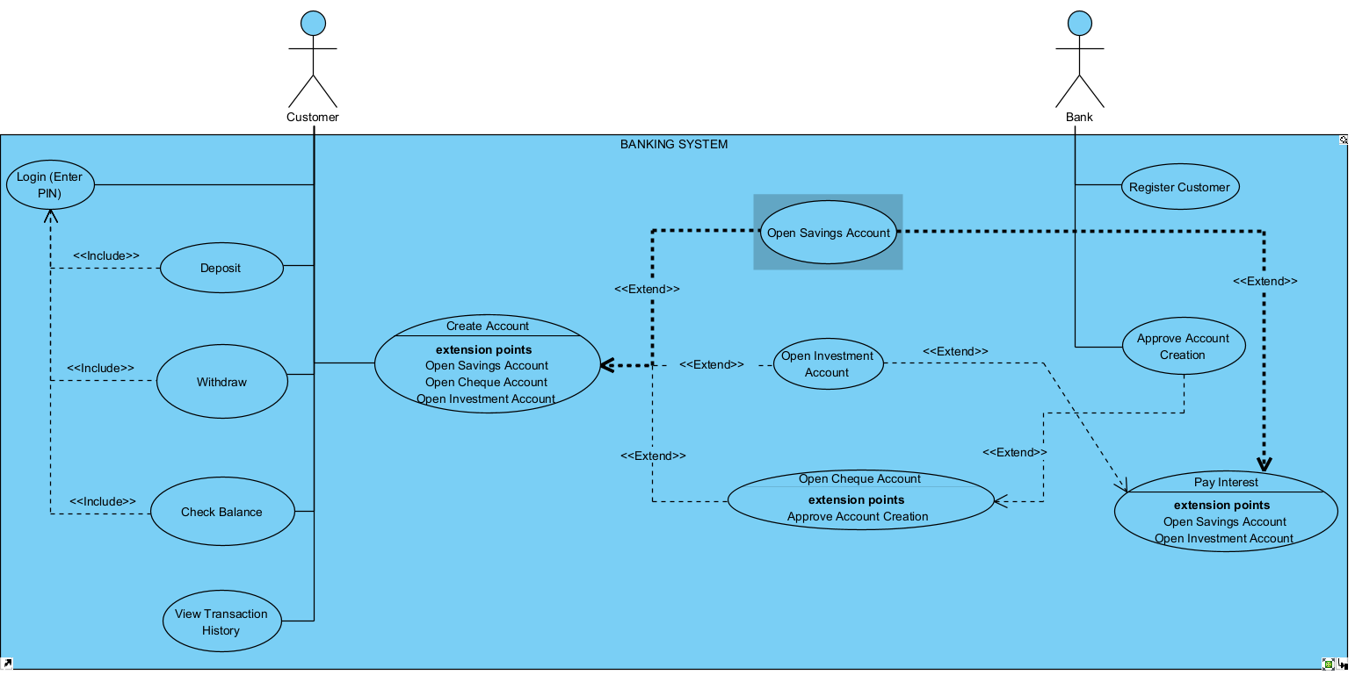

Class Diagram

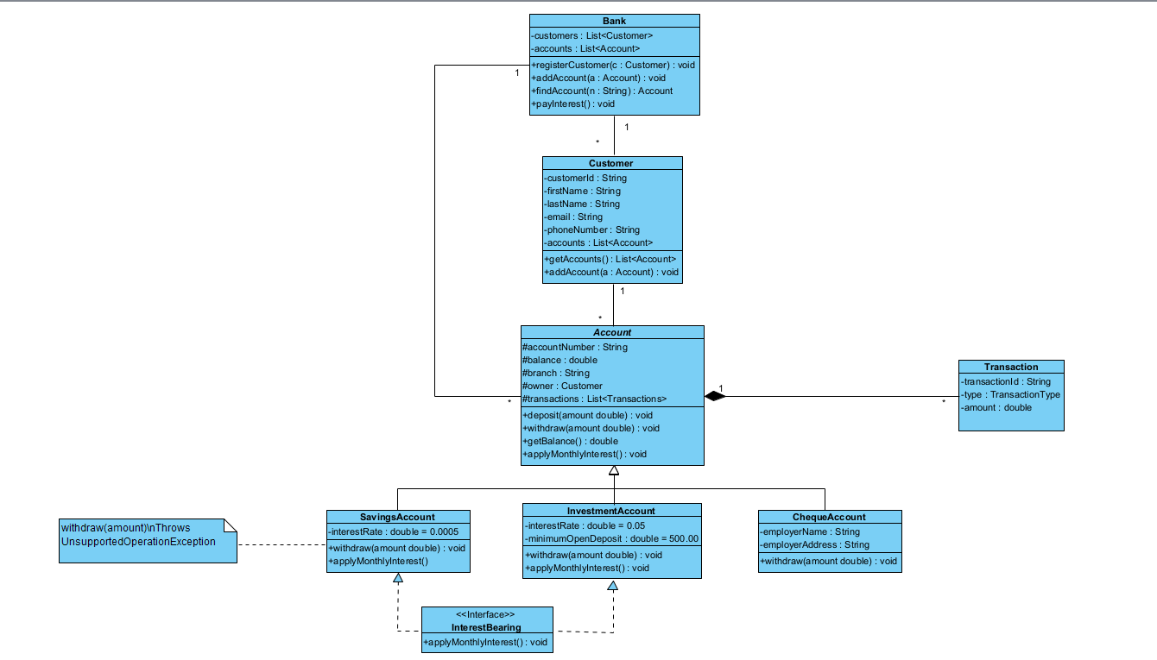

**Behavioural UML Modelling**

**Login Sequence Diagram**

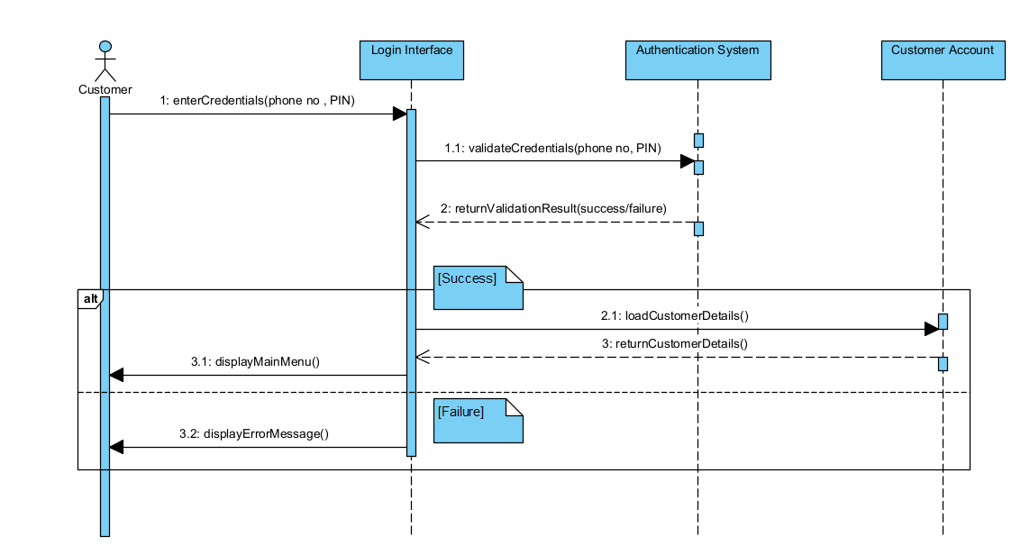

**Deposit Sequence Diagram**

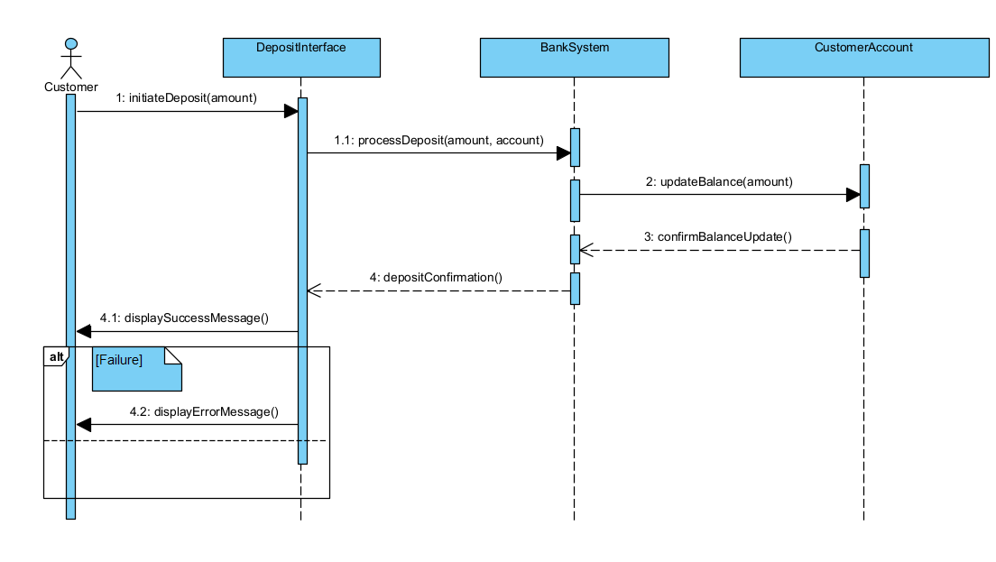

**Pay Interest State Diagram**

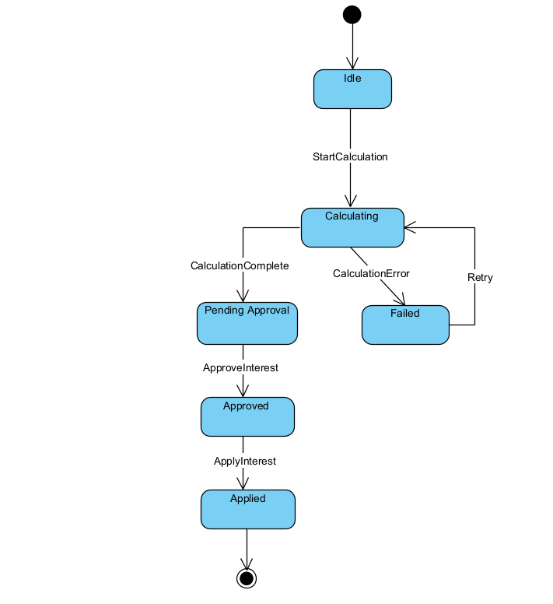

MEETING RECORD APPENDIX

**PROJECT:** BANKING SYSTEM

**INTERVIEWER:** BOAGO PABLO NKHII

**INTERVIEWEE**: MR. THEMBA MOENG

**DATE:** 17 SEPTEMBER 2025

**MODE:** TEAMS CALL

**PURPOSE**

The purpose of this interview is to gather requirements for the proposed Banking System. The system will allow customers to open and manage different types of accounts, perform transactions and provide bank staff with tools to manage the customers and accounts. The aim is to ensure the system supports both customer and administrative functions while meeting performance, security and usability standards

**INTERVIEW RECORD**

**Q1: What key services should the system provide for customers?**

A: Customers should be able to register, open and account, deposit and withdraw money as well as check balances and transaction history.

**Q2: What functions should bank staff have access to?**

A: Staff should be able to register new customers, create and manage customer accounts, monitor transactions and apply operations such as paying interest.

**Q3: Should customers be able to have more than one account?**

A: Yes, a customer be able to open different types of accounts namely, savings account, cheque account and an investment account.

**Q4: Do you require user authentication for both customers and staff?**

A: Yes, both groups must log in with a pin before accessing the system.

**Q5: What information must the system keep about transactions?**

A: Each transaction should store the amount and type (deposit, withdrawal, interest payment).

**Q6: How reliable should the system be?**

A: It must have 99% uptime to ensure customers can access services at almost all times.

**Q7: What are the expectations for performance?**

A: The system should respond to commands or input in real-time or close to real-time, ideally within 3ms.

**Q8: How secure should the system be?**

A: Data should be encrypted, and login should be implemented.

**Q9: What are the usability expectations?**

A: The interface must be user-friendly, suitable for both customers (who may have limited technical knowledge) and bank staff.